الاسـم: ...........................................................…….…............:Name اسم المركـز: .........................................................:Centre
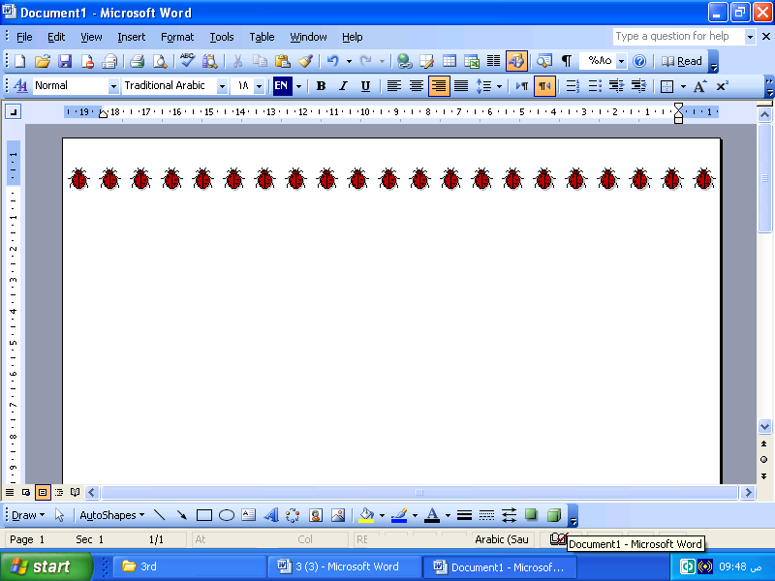
رقـم الجـلوس: ..................................................:Index No. رقـم المركـز:............................................:Centre No.

بسـم الله الرحـمن الرحـيم

Third Class
100

River Nile Stat - Ministry of Education

Al-Abeedia Secondary School for Girls
Experimental Exam (1) – School Year 2006 – 2007

Subject: English Language. Time: 3 Hours
[
Questions |  | Marks | Marked  by | Checked  by
- Comprehension
- Summary
- Language | A
- Language | B
- Language | C
- Language | D
- Composition
Total

Question One: Comprehension.
Read the passage then answer the
questions below.
Sudan is one of the richest countries in wildlife in Africa. This animal wealth belongs to all the Sudanese people and it is our duty to protect and preserve it. In the past people were allowed to hunt animals for food. They used traditional weapons such as spears, and nets. The amount they killed was limited. But when firearms were later introduced specially by those who hunt for commercial purposes, animals were killed in great numbers and some species became threatened with extinction. That was why the government established the department of wildlife, conservation and tourism to protect animals and arrest those who hunt without permission In some arts of the Sudan, there are several game parks and forest reserves where none may hunt or kill a wild animal. For example, Dinder Park and Nimule which is in the south of Juba on the boarder with Uganda. Visitors who go to Nimule Park can watch the magnificent sight of the hippos and crocodiles swimming in the river. The guides who accompany the visitors often warn them to be on look out for snakes, which are lying, in the thick grass. So national parks bring income to our country. Tourists come from various countries to see different kinds of animals and they bring with them hard currency such dollar, euro, franc and sterling. This money can improve our economy.

- Give short answers: (10m)

- Where is the Nimule Park? ____________________________________________________________________________________________
- Is it our duty to protect and preserve animals? _____________________________________________________________
- What is mean by hard currency? ___________________________________________________________________________________
- Why do the guides accompany the visitors? ____________________________________________________________________
- What are the game parks mentioned in the passage? _________________________________________________

- Draw a circle round the letter of the best answer:- (20m)

- The department of wildlife, conservation and tourism is established to ______________
A. bring income B. kill wild animals C. protect animals D. arrest people
DO NOT WRITE ON
THIS SHADED AREA

- Animals were not in danger in the past because ______________
A. firearms were used B. the number killed was limited
C. the number killed was so big D. the magnificent sights
- The underlined word “extinction” line 10 means ______________ .
A. great number B. purpose C. to die out D. hippos
- The neighbouring country mentioned in the passage is __________________.
A. Uganda B. Nimule C. tourist D. Sudan
- Sudan is one of the richest countries in ______________.
A. Juba B. Africa C. Arms D. Asia
- The animal wealth in Sudan belongs to ________________.
A. National Parks B. Visitors C. Nimule D. All the Sudanese people
- In the past people were allowed to hunt for ________________.
A. enjoyment B. commercial purposes C. spears and nets D. food
- The underlined word “They” line means ________________ .
A. games park B. animals C. people D. traditional weapons
- The best TITLE to this passage would be ______________
A. Wildlife in Sudan B. Africa
C. Thick grass in Sudan D. Crocodiles in Sudan
- Guides often warn visitors to be on look out for _______________________
A. forest B. snakes C. government D. grass
Question Two: Summary. (15m)

Read this passage carefully. Look for the main ideas and then in your own words write a summary. Your answer should be connected piece of writing.

To have good health people should use clean and safe drinking water. Safe drinking water is the water, which is free from all of the impurities that cause pollution. Water pollution causes many diseases such as typhoid, dysentery, cholera, diarrhea and many other diseases. Polluted water kills fish and other animals which drink from it. Water pollution is usually caused by people’s bad use of their water resources. They pollute water by throwing human and industrial waste into rivers, wells and natural lakes. People sometimes throw chemicals and pesticides into water supplies. People can prevent water pollution in their houses by cleaning and covering all the water containers.

Now answer questions (A) and (B):-

      - In not more than 15 words write about the diseases caused by polluted water.
______________________________________________________________________________________________________________________________________________
______________________________________________________________________________________________________________________________________________
______________________________________________________________________________________________________________________________________________
______________________________________________________________________________________________________________________________________________

      - In not more than 20 words explain how do people pollute water.
______________________________________________________________________________________________________________________________________________
______________________________________________________________________________________________________________________________________________
______________________________________________________________________________________________________________________________________________
______________________________________________________________________________________________________________________________________________

Question Three: Language. (40m)

- (I) Use the words at the end of each sentence to form a word that fits in the space. Use these endings. (5m)

-ive , -ous , -ment , -y , -able

- Radio, TV and newspapers are means of __________________________________________. (entertain)
- The lotus is an ___________________________________________________________ flower. (attract)
- Water is more _______________________________________ than gold. (value)
- Al-Tayib Salih is a _________________________________ Sudanese writer. (fame)
- The place is so __________________________________________ that I can’t hear you. (noise)

(II) Use the words at the end of each sentence to form a word that fits in the space.
Use these prefixes BEFORE each word. (5m)

in- , over- , im- , re- , dis-

    - The sky is cloudy. It is ________________________________________ to see the sun. (possible)
    - Mona likes fish but she __________________________________________ chicken.(like)
    - Birds migrate in winter when the food is ________________________________ . (sufficient)
    - As a result of eating too much, she became ________________________________ . (weight)
    - The wind is one of the ________________________________________ energy sources. (newable)

- From this list of words below choose the best word that fits in the space. (10m)
talk – Susan - get - each - twice - slipped - future - about - rainy - John

John and ________________ first met one ____________________ afternoon when ____________________ helped Susan after she had ____________________ in the mud. They usually meet __________________ a week and often visited ______________ other’s family. They began to _____________ seriously ___________________ their ____________________ and finally they decided to ___________________ married.

- Put the verbs in brackets in their correct form. (10m)

- They (go) ___________________________________________________ to the park last Friday
- Listen! The birds(sing) _________________________________________ on the tree.
- When we (reach) ________________ the station, the bus (already leave) ____________________________.
- While she (watch) ______________________________ TV, the electricity went out suddenly.
- Salih (get) ________________________________________ married next month.
- She (not go) ________________________________________________ to school every Saturday.
- If it (rain) _______________________________________________ , we won’t play football.
- I don’t like (read) ___________________________________ magic stories.
- Maria (not cook) _______________________________________________ food yet.

- Complete sentence (B) so that it has a similar meaning to sentence(A) using the given words. You must use from TWO to FIVE words in each space: (10m)

- (A) They are writing letters now.
(being) (B) Letters _________________________________________________________________________________ .
- (A) If she doesn’t read hard, she can not pass the test.
(Unless) (B) ___________________________________________________________________________________________ .
- (A) He likes fish more than chicken.
(prefer) (B) He __________ ______________________________________________________________________________ .
- (A) Nurses often take care of the sick people.
(look) (B) Nurses __________________________________________________________________________________ .
- (A) The place is dark. I can’t see anything.
(so) (B) The place ______________________________________________________________________________ .

Question Four: Composition. (15m)

Marks will be given to correct grammar, punctuation, tidy and neat presentation.

Many people sank in the river in front of your eyes. Many people were drowned. Some swam to the shore, few were saved, by others. A policeman asks you to tell him about what had happened.

Write a composition of about (150 – 180) words describing the accident:

_______________________________________________________________________________________________________________________________________________
________________________________________________________________________________________________________________________________________________
________________________________________________________________________________________________________________________________________________
________________________________________________________________________________________________________________________________________________
________________________________________________________________________________________________________________________________________________
________________________________________________________________________________________________________________________________________________
________________________________________________________________________________________________________________________________________________
________________________________________________________________________________________________________________________________________________
________________________________________________________________________________________________________________________________________________
________________________________________________________________________________________________________________________________________________
________________________________________________________________________________________________________________________________________________
________________________________________________________________________________________________________________________________________________
________________________________________________________________________________________________________________________________________________
________________________________________________________________________________________________________________________________________________
________________________________________________________________________________________________________________________________________________
________________________________________________________________________________________________________________________________________________
________________________________________________________________________________________________________________________________________________
________________________________________________________________________________________________________________________________________________
________________________________________________________________________________________________________________________________________________
________________________________________________________________________________________________________________________________________________
________________________________________________________________________________________________________________________________________________

