بســم الله الرحمـن الرحـيم
إدارة تعليم الأساس ( قــطاع البــاوقــة )

مـدرســــة التكــاوين الأسـاسـية بنــات

الاســم: …………………………………………………… امتحـان تجـريبي لشـهر: .................................................................................................
English Language 5th class Time: an hour

Question (1) Answer the following questions. (10m)أجب علي الأسئلة التالية

- This is my ………………………………………………………..…………..………………………… .

- Have you got a book? …………………………………………………………………………………………… .



- Where is the bird? 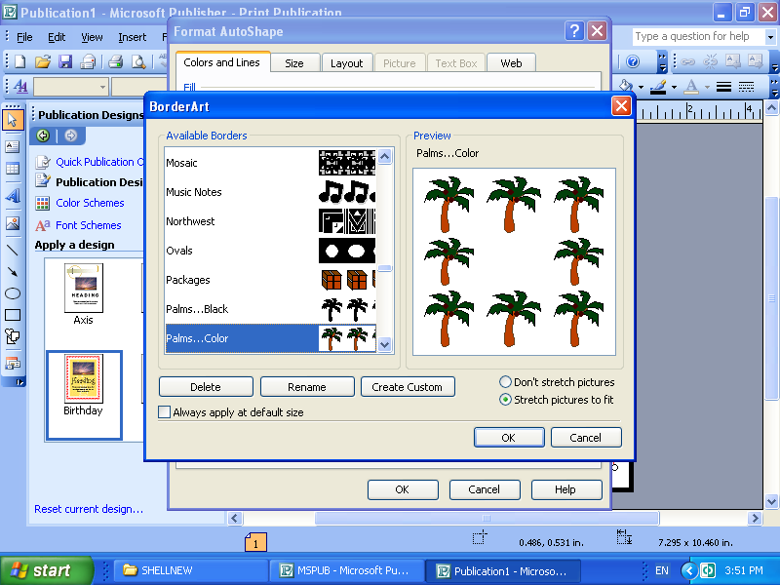 …………………….……..……………………………….……………………… .

- Where is the triangle? …………………………….………………………………..………… .

- What is that? ……………………………………………..……….. .
 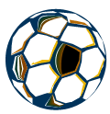 
- Where is the ball? ………………………………………..………………………… .

- What colour is the board? …………………………………..……………………………………..………………… .
- Are you Sudanese? ……………………………………………………………………………………...…………………… .
- How old are you? ………………………………………………………………………….…………….…..………………… .
- Is Nawal a boy? ……………………………………………………………………..……………………..………………… .

Question (2) Write the missing letters: (3m)اكتب الحروف غير الموجودة حسب الترتيب

c , __ , __ , f , __ , h , i , __ , k , l , __ , n , __ p.

Question (3) Write the missing letters: (3m)اكتب الارقام غير الموجودة بالترتيب

- 18, __ , __ , 21 , __ , __ , 24.
- 32 , __ 34 , __ , 36.

Question (4) Complete with the suitable word: (5m) اكمل بوضع الكلمة المناسبة

@ mother - daughter - He - Sudanese - son - Zeinab - is - man - a - girl @

This is a ___________________ family. Hamid is a _________________. He is the father. ___________________ is ______________ woman. She is the ____________________. Kamal _____________________ a boy. _______________ is the _________________. Nawal is a __________________. She is the ____________________________.

Question (5) Match pictures with words: (4m) ضع الكلمة مع الصورة المناسبة

(A) | (A) | (B)
- ear | …………………………………………. | 
- key | …………………………………………. | 
- watch | …………………………………………. | 
- finger | …………………………………………. | 
- tree | ………………………………………….
- ball | …………………………………………. | 
- mouth | ………………………………………….
- eye | …………………………………………. | 

Question (6): Underline the correct word (5m)

Question (7): Write the missing letter: (5m)

- fa__ily. 6. Zei__ab.
- mot__er. 7. g__rl.
- y__llow. 8. sho__s.
- d__ughter. 9. bi__ycle.
- R__da. 10. __ife.

- rluer ruler erurl
- spoon sonop opnos
- agb bag gba
- ntiar anrti train
- table betal latbe

Question (7) Match (A) with (B): (5m)

A | A | B
- Hamid | ………………………………….…………… | head
- toes | ………………………………….…………… | colour
- hair | ………………………………….…………… | father
- Nawal | ………………………………….…………… | foot
- red | ………………………………….…………… | girl

Best wishes
Mohamad Abakar

